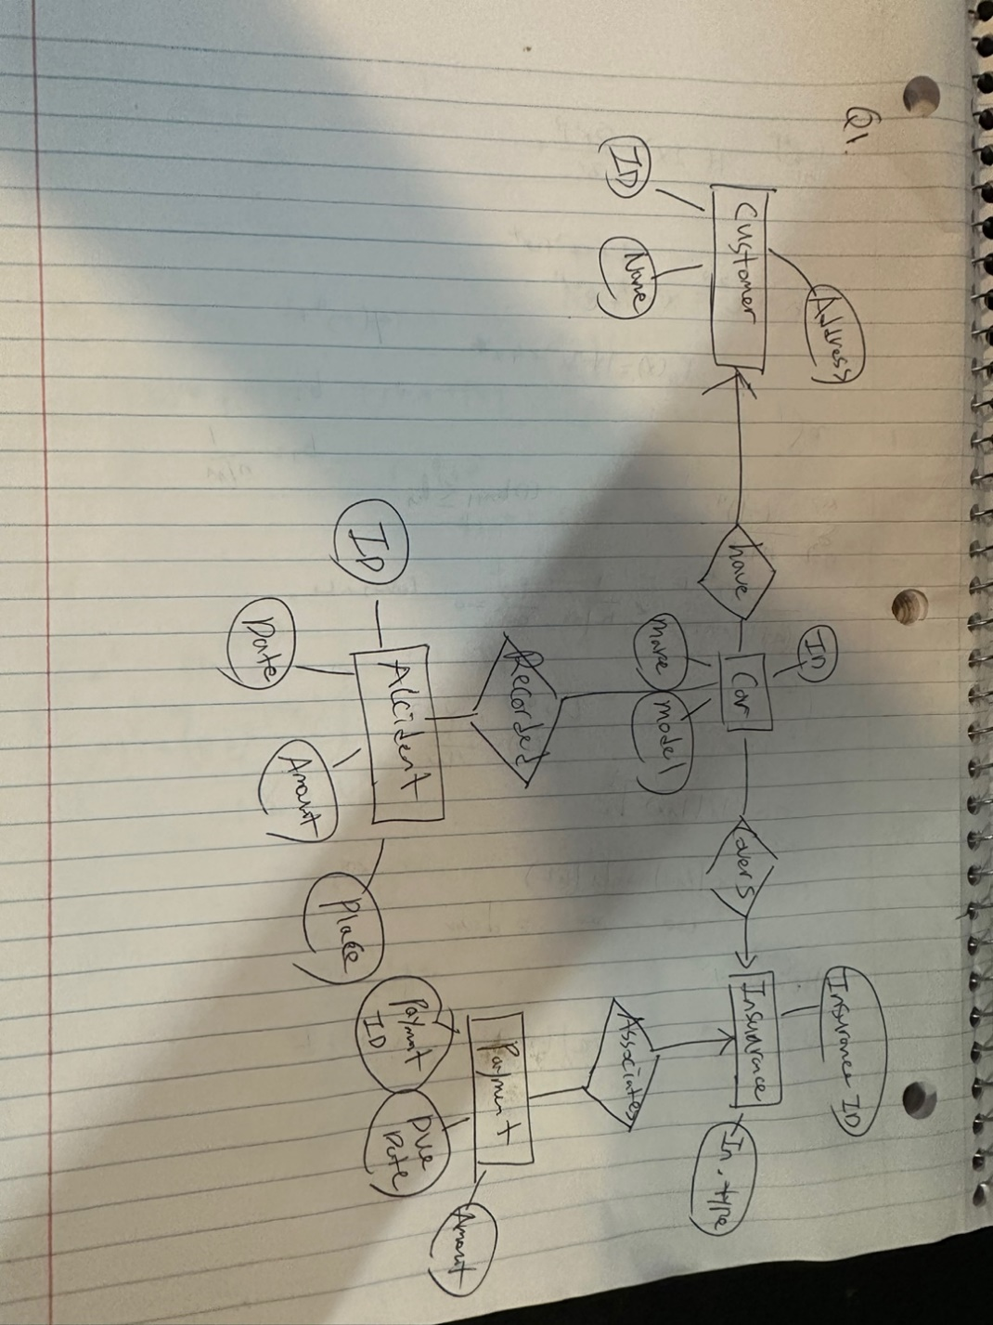

1. Construct an ER diagram for a car insurance company. The customers of the company own one or more cars each. Each car has zero or more recorded accidents. Each insurance policy covers one or more cars and has one or more payments associated with it. Each payment is for a  
particular period of time, has a due date, and has a payment received date.

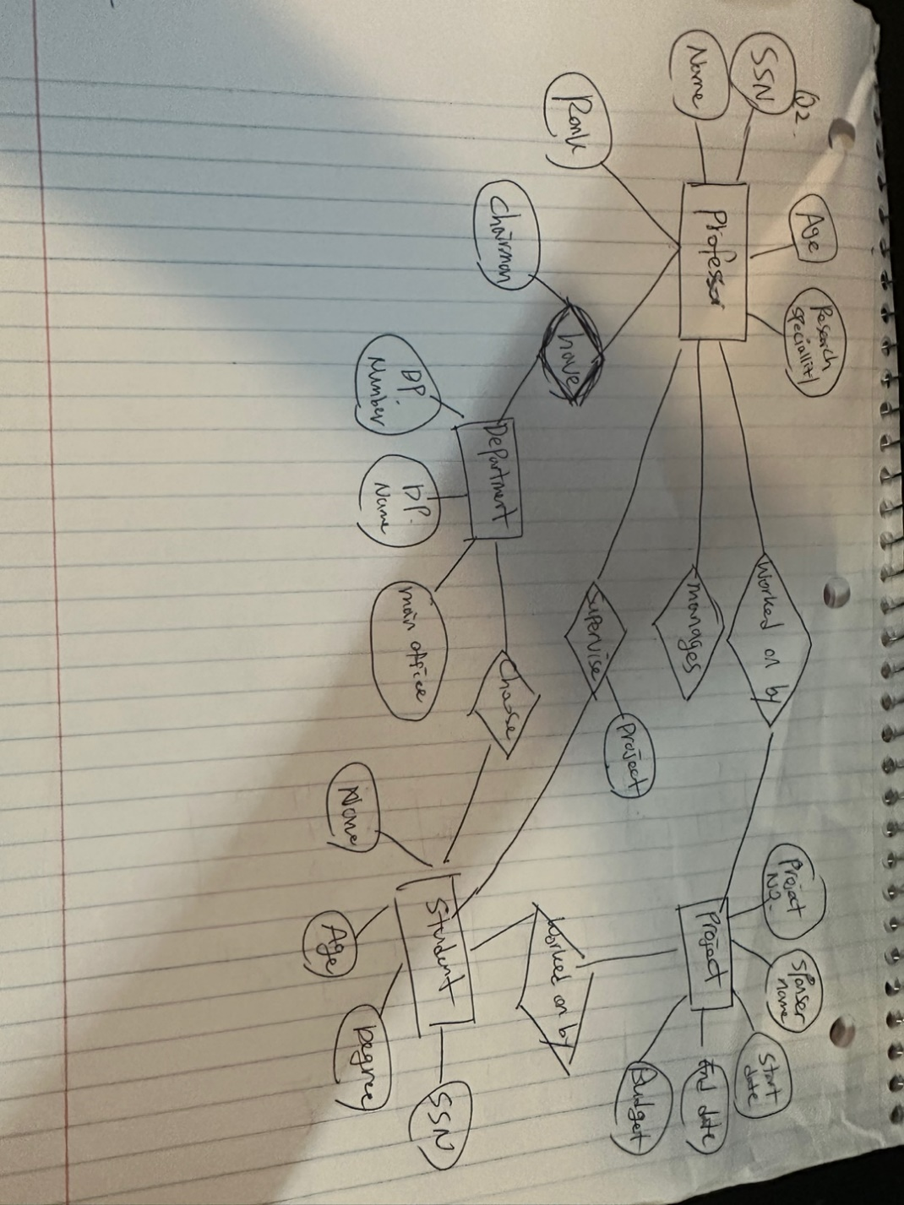

2. Construct an ER diagram for a university database, according to the following specifications: